Standard Operating Procedures

--Bose ElectroForce Biodynamic System

This S.O.P is a quick guide designed for compression test in Rm 1A26. All personnel should go through this S.O.P, the manual and training session scheduled with group assistant before s/he starts his/her research and tests. The content is intended to serve as one of the resources for the instrument’s proper operation but not the only one. The following is focused on its application on a quick start for the compression test, and the storage and plotting for measured data using computer. For any other usage (such as dynamic test with high frequency or with fluid flow circulation) and specifications of this instrument, please refer to the Manual or speak to the technician or assistant.

# Overview

The Bose testing system comprises two parts: the mechanic to carry out tests and the host software “Wintest”, once executed will let the mechanic carry out the commanded actions.

The Maxim Load Force the system can handle is 20 Newton, please be advised that any forces larger than this (20 N) will break the sensor. For any attempt to measure forces greater than 20 N, such as the compression for a PCL/metal parts, please refer to the contact information in the appendix and schedule a test with different lab.

Quick Start

Make sure the machine is leveled.

Turn on the power supply first, then the PCI box (in this order), and the computer.

Login to the “Wintest” Account by pressing “Enter” (i. e. no password needed);

Run the “Wintest 4” Program; 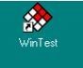

Once the program is open, there will be a prompt windows for selecting the project file to set the system parameters, for now we use “………”, please create a subfolder with your name in the current folder, and store a copy of the said file in order to preserve the current settings;

Once logged in, you will see a window like the following picture, showing information such as test status, reading for different meters (i. e. the load and displacement), and control units, such as “RUN”, “STOP”, and “STOP LEVEL”, etc.

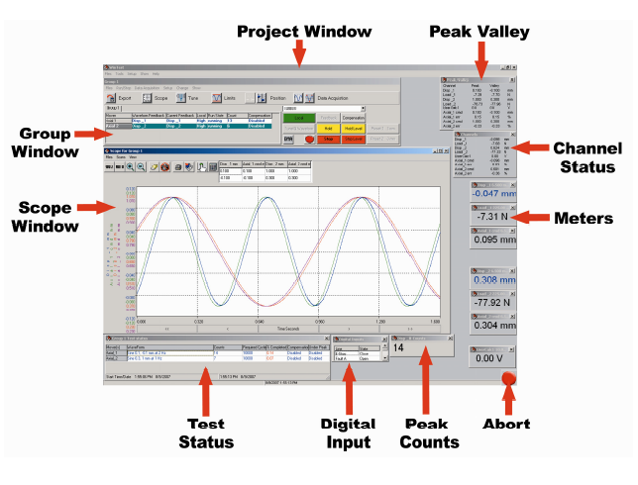

Check the transducers are working properly: pull (upwards) the actuator to create a movement of the linear motor; and there should be a negative feedback for displacement. Then press the load cell gently (do not exceed the force the load cell can handel, i.e. 20N), and the load feedback should be negative.

  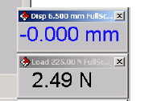

Motor Check Load Cell Check Displacement and load reading

If the transducers are working properly, click the **Feedback** button, to choose the feedback, and the parameter that you want to control in the experiment, in most cases, choose “Disp(lacement)”. The status of current feedback can be checked in the Group Window.

Putting the chamber on, be careful with the load cell, and make sure tighten the screws on both the load cell and motor, once that’s done, release the clutches.

## Setting the limits:

In the drop down manual, choose **Setup** 🡪 **Limits**. This can also be achieved by pressing the **Limits** button.

In the Limit window, choose channel **Disp**. The limits should often be just above the desired displacements, for example, if the desired range for a sine wave is from 0 to +2 mm, then the limits should be -1 and +3 mm. After that, do the same with the channel **Load**.

Tare: because of the weight of the chamber and the clutch hangings on the Load cell, and/or the displacement already occurred on the actuator (explained in the following text), there could be readings on either or both channel(s). In order to get a “clean” reading, you may choose to set the reading to “0” digitally by using the **Tare** button. Remember this only set the number to zero on the screen, which you can use as a baseline, your actual load and displacement have not changed. For most experiments, this is unnecessary, because the Load and Displacement is the difference between your measured value and its initial value. Use with Cation.

Turn the **Local** on High, this will enable the communication between the PC and the instrument. After the local is on, remember to put your hand ready to press down the **Emergency Stop** button for any anomalies in order to protect the system.

Put your sample in; and use the **Position** button to adjust the position so that the surface of the clutch will contact the sample, yet no compression will be applied.

For the first run, it is recommended to do a test run so the system can adjust its control parameters for the optimized measurement. In order to do so, click the **TunelQ Waveform** button, and choose waveform **Sine**. Then press **TunelQ Run**.

The system will finish this TunelQ Run process on its own. Once finished, replace with a new sample and get ready for the experiment.

## The Test

After the above steps, put the sample to be measured in, press **TunelQ Waveform** button, instead of Sine, and choose **Ramp** for the compression test. The desired displacement can be typed in manually, and the compression rate should be a value from literature in order to make your data comparable with other researches.

After setting up the parameters, click the **Run** button, then **Start (Do Not Use “Zero Start”)**.

The test will stop after reaching predefined displacement. Then it can either hold the position or go back to a predefined position to release the sample, see reference for the **Preset** buttons.

## Data Acquisition

There are many ways to record data. It is recommended to use Timed Data from Data Acquisition tab.

In this window you can define the desired measuring time in Scan Time as seconds. The Scan Points defines the number of data will acquired in the defined Scan Time. Then you can choose the location and name for the data file in File Info.

Choose Immediate, then press **Start** button.

Now the system start recording the data, press **Run** to start the test as mentioned above.

For measurement larger than 20 N, please contact Louis Roth in 1A53.4 through (306) 966-5302 or [louis.roth@usask.ca](mailto:louis.roth@usask.ca).

Appendix

1. Replace the Load Sensor.

The connectors are Red 1, Black 2, White 3, Green 4 (Center), and Sliver 5 (Ground).